Symmetric bending
Normal stresses in bending
$$y$$
Consider a straight prismatic beam made of homogeneous material, having a cross-sectional area that is symmetrical with respect to an axis, and the bending moment is applied about an axis perpendicular to this axis of symmetry (principal axes) as shown. If the bending moment is constant, it is called pure bending (simple or symmetric bending) | 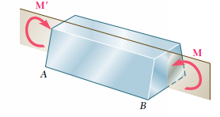  $$z$$  $$x$$
By using a highly deformable material such as rubber, we can illustrate what happens when a straight prismatic member is subjected to a bending moment. Consider the undeformed bar which has a square cross section and is marked with longitudinal and transverse grid lines. When a bending moment is applied, it tends to distort these lines into the pattern shown. Notice that the longitudinal lines become curved and the vertical transverse lines remain straight and yet undergo a rotation. The plane cross section remain plane after bending. The bending moment causes the material within the bottom portion of the bar to stretch and the material within the top portion to compress. Consequently, between these two regions there must be a surface, called the neutral surface, in which longitudinal fibers of the material will not undergo any change in length.
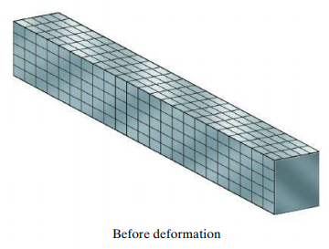 | 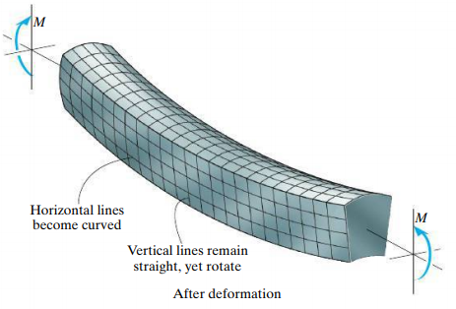
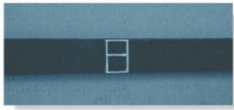 | 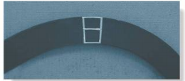

Consider a prismatic beam with a cross section with vertical axis of symmetry subjected to pure bending moment in the plane of symmetry. Let us consider the internal loading by cutting the beam at C. | 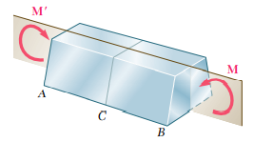  $$y$$  $$z$$  $$x$$  $$y$$
Consider a small elemental area $dA$ on the cross section which is at a distance $(y,z)$ from the $y$ and $z$ axes. The three stress components acting at that location can be considered as normal stress $σ_{xx}$ and two shear stresses $τ_{xy}$ and $τ_{xz}.$ | 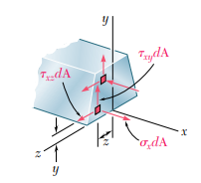  $$M_{z}$$
From the equilibrium consideration,
$$ΣF_{x}=0 ≫ \int{σ_{xx}} dA=0$$ | $$ΣM_{x}=0 ≫ \int{τ_{xz}} dA y-\int{τ_{xy}} dA z=0$$
$$ΣF_{y}=0 ≫ \int{τ_{xy}} dA=0$$ | $$ΣM_{y}=0 ≫ \int{σ_{xx}}dA z=0$$
$$ΣF_{z}=0 ≫ \int{τ_{xz}} dA=0$$ | $$ΣM_{z}=0 ≫ -M_{z}-\int{σ_{xx}} dA y=0$$

Let the member be divided in to a large number of small cubic elements whose faces are parallel to the co-ordinate planes. When the beam is subjected to pure bending (constant bending moment M), all the faces represented in the two projections are at $90°$ to each other. Hence, we can conclude that $γ_{xy}=γ_{xz}=0$.  Therefore, $τ_{xy}=τ_{xz}=0$.  The only non-zero stress component on the cross section is $σ_{xx}$. Hence, at any point of a slender member subjected to pure bending, we have a state of uni-axial stress state. | 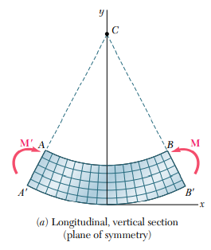
 | 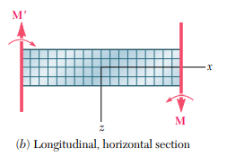

Referring to the figure, for a positive bending moment $M$ (sagging moment), the line $AB$ will have a decrease and $A’B’$ will have an increase in length. So, the stress $σ_{xx}$and strain $ε_{xx}$ are negative (compressive) on the upper portion and positive (tensile) on the bottom part. | 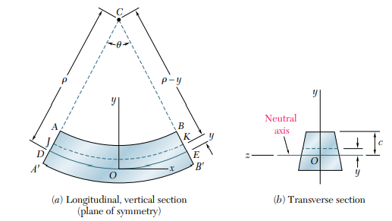
Therefore, there must be a surface parallel to the upper and lower surfaces, where $σ_{xx}$ and $ε_{xx}$ are zero. This surface is known as neutral surface and the line of intersection of the neutral surface with the cross section is known as neutral axis. Consider the origin of co-ordinates at the neutral surface.
Let $ρ$ denotes the radius of arc $DE$, $θ$ denotes the central angle corresponding to $DE$, and L denotes the undeformed length of $DE$.
$$L=ρθ$$
Consider the element JK situated at a distance y above the neutral surface. After bending, JK bends to an arc of length $L^{'}=(ρ-y)θ$.
The deformation of JK, $δ=L^{'}-L=\left(ρ-y\right)θ-ρθ=-yθ$.
The longitudinal strain on JK, $ε_{xx}=\frac{δ}{L}=\frac{-yθ}{ρθ}=\frac{-y}{ρ}$
The normal stress on the element JK, $σ_{xx}=Eε_{xx}=\frac{-E}{ρ}y$
$$\int{σ_{xx}} dA=0≫≫ \int{\frac{-E}{ρ}y}dA=0$$  $$\frac{-E}{ρ}\int{y}dA=0 ≫≫\int{y}dA=0$$  $$A\overline{y}=0≫≫ \overline{y}=0$$  That is, the neutral axis passes through the centroid of the cross section | $$-M_{z}-\int{σ_{xx}} dA y=0≫\int{σ_{xx}}ydA=-M_{z}$$  $$\int{\frac{-E}{ρ}y}ydA=-M_{z}≫\frac{E}{ρ}\int{y^{2}}dA=M_{z}$$  $\int{y^{2}}dA=I_{zz}$, moment of inertia of the cross section of the beam w.r.t the z-axis (neutral axis).  $$\frac{EI_{zz}}{ρ}=M_{z}$$
$${ ∴σ}_{xx}=\frac{-E}{ρ}y=-\frac{M_{z}}{I_{zz}}y$$
This is known as flexure formula.
When $y=c$, (top surface) the stress is maximum.
${ ∴σ}_{xx} (\max{ }) =-\frac{M_{z}}{\frac{I_{zz}}{c}}=-\frac{M_{z}}{S}$ $, S$ is known as the section modulus.
The bending stress is maximum at the top and bottom surfaces where y is maximum. One will be a compressive stress and the other will be a tensile stress depending upon the sign of the bending moment.

Even though, the results are derived for pure bending (constant bending moment and no shear force), it can be used for cases where shear forces are also present if the beam is slender (i.e., cross section is small compared to its length). Such beams are called Euler-Bernoulli beams (thin beams). Due to bending, cross sectional planes rotate and plane sections will remain plane after bending.

If cross section is large compared to the length, they are called Timoshenko beams (thick beams) and, in such beams, the effect of shear deformation cannot be neglected. Here, the cross-sectional planes will not remain plane after bending as shown below. In such cases, Timoshenko beam theory has to be applied.
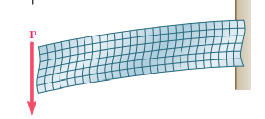 | 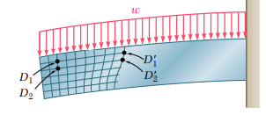
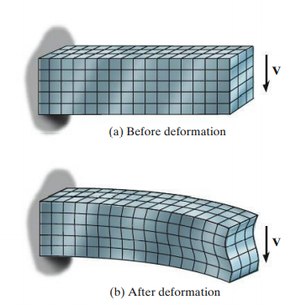

#Example 1  A cast iron machine part is acted upon by the $3 kN.m$ couple as shown. Knowing that $E=165 GPa$ and neglecting the effect of fillets, determine (a) the maximum tensile and compressive streses in the casting, (b) the radius of curvature of the casting. | 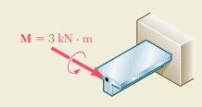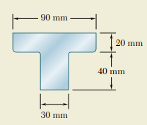  $$M_{z}$$  $$y$$  $$x$$  $$z$$
First, we have to locate the centroid of the cross section through which the neutral axis (z-axis) passes.

$A_{i}$ ${mm}^{2}$ $y_{i}$ mm $$A_{i}y_{i}$$  1. $$20×90=1800$$ $$50$$ $$90000$$  2. $$40×30=1200$$ $$20$$ $$24000$$  $${ΣA}_{i}=3000$$ $${ΣA}_{i}y_{i}=114000$$  $$\overline{y}=\frac{{ΣA}_{i}y_{i}}{{ΣA}_{i}}=38 mm$$ | 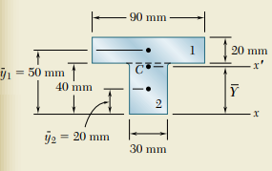  $$z$$
Moment of inertia of the cross-section about the neutral axis (centroidal z-axis)  $$I_{zz}=\left\{\frac{90×{20}^{3}}{12}+1800×{12}^{2}\right\}+\left\{\frac{30×{40}^{3}}{12}+1200×{18}^{2}\right\}$$  $$I_{zz}=868×{10}^{3} {mm}^{4}=868×{10}^{-9} m^{4}$$ | 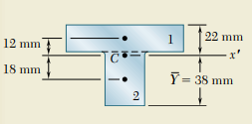  $$z$$
The flexure formula is $σ_{xx}=-\frac{M_{z}}{I_{zz}}y$
Here, bending moment is negative as per the sign convention.
$$M_{z}=-3 kN.m$$
The bending stress is maximum at the extreme surfaces $(y=+22 mm and y=-38 mm)$
$${σ_{xx}}_{y=+22mm}=-\frac{\left(-3×{10}^{3}N.m\right)}{868×{10}^{-9} m^{4}}\left(22×{10}^{-3}m\right)=+76×{10}^{6} Pa$$
$${σ_{xx}}_{y=-38mm}=-\frac{\left(-3×{10}^{3}N.m\right)}{868×{10}^{-9} m^{4}}\left(-38×{10}^{-3}m\right)=-131.6×{10}^{6} Pa$$
$$σ_{xx}=\frac{-E}{ρ}y=-\frac{M_{z}}{I_{zz}}y ≫≫\frac{1}{ρ}=\frac{M_{z}}{EI_{zz}}=\frac{\left(-3×{10}^{3}N.m\right)}{\left(165×{10}^{9}\frac{N}{m^{2}}\right)\left(868×{10}^{-9} m^{4}\right)}= -20.95×{10}^{-3}m^{-1}$$
Negative sign shows that the curvature is convex. The radius of curvature,
$$ρ=47.7 m$$

#Example 2  The rectangular tube shown is extruded from an aluminium alloy for which $σ_{Y}=150 MPa, σ_{U}=300 MPa, E=70 GPa$. Neglecting the effects of fillets, determine the maximum bending moment which can be applied considering a factor of safety of 3. Also determine the radius of curvature of the tube. | 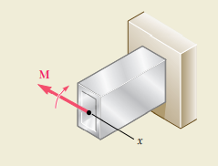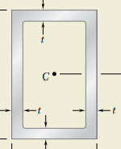  z  y  z  y  x  8 mm  120 mm  80 mm  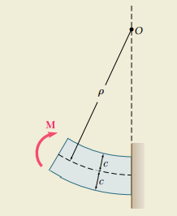
Since, the cross-section is symmetrical to both y and z axes, the centroid is at its centre. The neutral axis is the z-axis.
$$I_{zz}=\left\{\frac{80×{120}^{3}}{12}\right\}-\left\{\frac{64×{104}^{3}}{12}\right\}=5521×{10}^{3} {mm}^{4}=5521×{10}^{-9} m^{4}$$
The allowable stress, $σ_{allow}=\frac{σ_{U}}{Factor of safety}=\frac{300 MPa}{3}=100 MPa <σ_{Y}$
The allowable stress is less than the yield stress. Therefore, the tube remains within the elastic limit. Hence, the flexure formula is applicable.
The flexure formula is $σ_{xx}=-\frac{M_{z}}{I_{zz}}y$
Here, bending moment is positive as per the sign convention.
$$M_{z}=M$$
The bending stress is maximum at the extreme surfaces $(y=±60 mm)$
$$100×{10}^{6}\frac{N}{m^{2}}=-\frac{M}{5521×{10}^{-9} m^{4}}\left(60×{10}^{-3}m\right)≫≫M=9201 N.m$$

$$σ_{xx}=\frac{-E}{ρ}y=-\frac{M_{z}}{I_{zz}}y ≫≫\frac{1}{ρ}=\frac{M_{z}}{EI_{zz}}=\frac{\left(9201N.m\right)}{\left(70×{10}^{9}\frac{N}{m^{2}}\right)\left(5521×{10}^{-9} m^{4}\right)}= +23.8×{10}^{-3}m^{-1}$$
Negative sign shows that the curvature is concave. The radius of curvature,
$$ρ=42 m$$

#Example 3  The $W360 ×79$ rolled-steel beam $(section modulus=1270{×{10}^{3}mm}^{3})$ $AC$ is simply supported and carries the uniformly distributed load shown. Determine the location and magnitude of the maximum normal stress due to bending. | 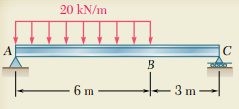
Considering the free-body diagram of the beam,  $$ΣF_{x}=0 ≫≫ X_{A}=0$$  $$ΣM_{A}=0≫≫ R_{C}×9m- 20\frac{kN}{m}×6m×3m=0≫ R_{C}=40 kN$$  $$ΣF_{y}=0 ≫≫ R_{C}+Y_{A}-20\frac{kN}{m}×6m=0 ≫≫Y_{A}=80 kN$$ |   $$X_{A}$$  $$R_{C}$$  $$Y_{A}$$
Section 1-1 $(0≤x≤6 m)$  $$ΣF_{y}=0 ≫≫ Y_{A}-V_{1}-20\frac{kN}{m}×x=0$$  $$V_{1}=80-20x kN \left\{\begin{matrix}x=0, V_{1}=80 kN \\ x=6m, V_{1}=-40 kN\end{matrix}\right\}$$  $$ΣM_{1-1}=0 ≫≫ {-Y}_{A}×x+M_{1}+20\frac{kN}{m}×\frac{x^{2}}{2}=0$$  $$M_{1}=80x-{10x}^{2} kNm\left\{\begin{matrix}x=0, M_{1}=0 \\ x=6m, M_{1}=120 kNm\end{matrix}\right\}$$ |   $$M_{1}$$  $$V_{1}$$  $$x$$  $$R_{C}$$  $$Y_{A}$$
Section 2-2 $(6m≤x≤9 m)$  $$ΣF_{y}=0 ≫≫ Y_{A}-V_{2}-20\frac{kN}{m}×6=0$$  $$V_{2}=-40 kN \left\{\begin{matrix}x=6m, V_{2}=-40 kN \\ x=9m, V_{2}=-40 kN\end{matrix}\right\}$$  $$ΣM_{2-2}=0 ≫≫ {-Y}_{A}×x+M_{2}+20\frac{kN}{m}×6×\left(x-3\right)=0$$  $$M_{2}=80x-120(x-3) kNm\left\{\begin{matrix}x=6m, M_{2}=120 kNm \\ x=9m, M_{2}=0\end{matrix}\right\}$$ |   $$V_{2}$$  $$M_{2}$$  $$x$$  $$R_{C}$$  $$Y_{A}$$
The shear force becomes zero at D in section 1-1.  $$80-20x=0≫≫x=4 m$$  The maximum bending moment corresponding to point D  $$M_{1}=80x-{10x}^{2}=80×4-10×4^{2}=160 kN.m$$  Neglecting the effect of shear deformation, the magnitude of maximum normal stress  $$σ_{xx}=\frac{M_{z max}}{S}=\frac{160×{10}^{3} N.m}{1270×{10}^{-6}m^{3}}=126×{10}^{3} Pa$$ | 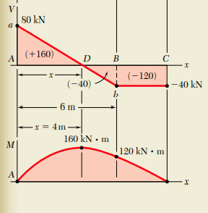

Exercise 1  Two vertical forces are applied to a beam of the cross section shown. Determine the maximum tensile and compressive stresses in portion BC of the beam | 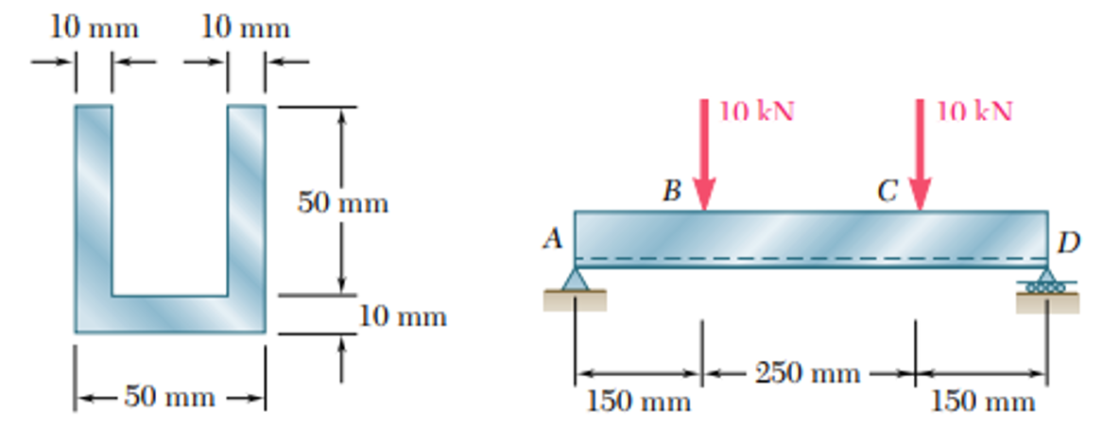

Exercise 2  The beam shown is made of nylon for which the allowable stress is 24 MPa in tension and 30 MPa in compression. Determine the largest moment M that can be applied to the beam |  | 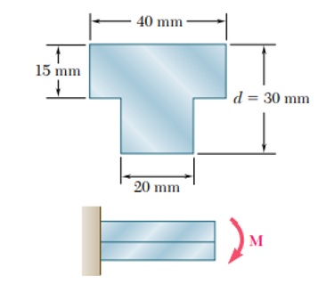
Exercise 3  A rigid steel bar $DEF$ is welded to the straight steel beam $AB$ of cross-section $50 mm×50 mm$. Draw the shear force and bending moment diagram of the beam AB for the load shown. Determine the maximum bending developed in the beam and its location. |  | $$50 kN/m$$  $$160 kN$$  $$8m$$  $$3m$$  $$5m$$  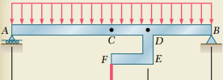
Exercise 4  A 5m long, simply supported steel beam $AD$ with rectangular cross-section is to carry loads as shown. The allowable normal stress for the grade of steel used is $160 MPa$. If the width of the beam is $50 mm$, what should be its depth $h$? | 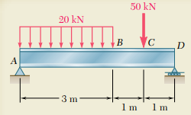  $$50 mm$$  $$h$$  $$/m$$
Exercise 5  Select a wide flanged beam for the above instead of rectangular section. |  | 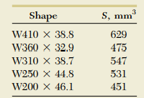  $${×10}^{3}$$
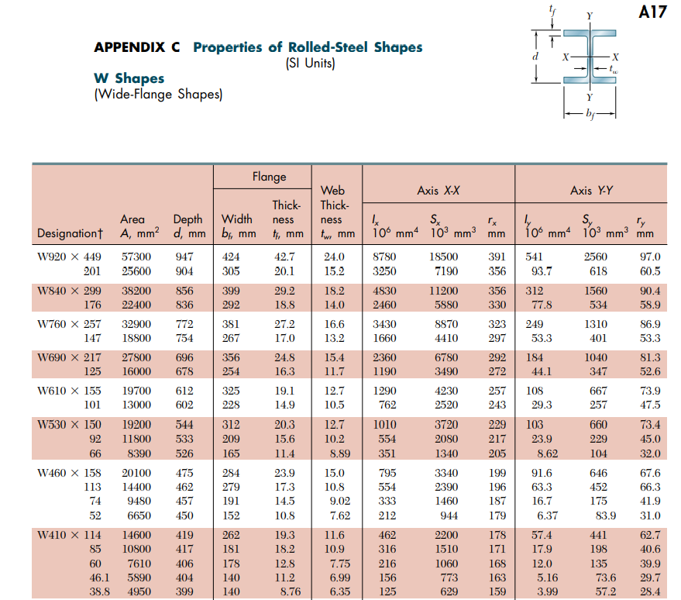

References:
- Mechanics of Materials, 2/e, J. M. Gere & S. P.Timoshenko, CBS Publishers.
- Mechanics of Materials, 6/e, F.P. Beer & E. R. Johnston, McGraw Hill
- Engineering Mechanics of Solids, 2/e, E. P. Popov, Pearson Education Asia.
- Mechanics of Materials, 9/e, R. C. Hibbeler, Prentice Hall.

